*ISAD3000 Capstone Computing Project 1 Final Submission Group Report*

***Group E8: Amristar Industry Project [Virtual Jukebox]***

Group Members:

Austin Bevacqua, Bradley van der Zwan, Dillon Vincent,   
Ryan Webster, Tanaka Chitete

Table of Contents

***Capstone Final Submission Group Report*** ***2***

Study Contract **2**

Submitted Deliverables **3**

Agile Report **4**

Client/Supervisor Meetings 4

Supervisor Meeting Summaries per Milestone 4

Group Meetings 4

Start/End of Sprint Meetings 5

Stand-up Meetings 5

Group Meeting Summaries per Milestone 5

Progress Tracking 5

Group Toggl Summaries 9

# ***Capstone Final Submission Group Report***

*Group E8: Amristar Industry Project [Virtual Jukebox]*

# Study Contract

See below for the study contract the group has created, and the semester 1 assessment and deliverables sheet provided by Amristar – the industry partner.

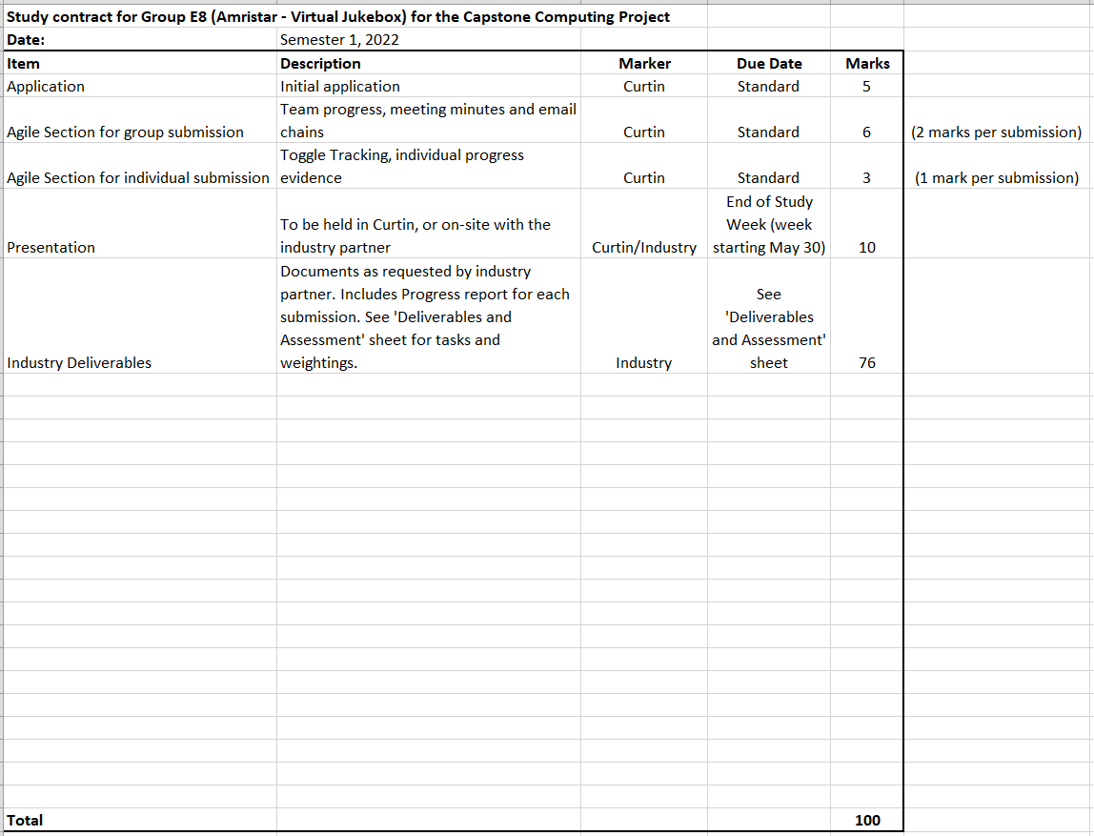

# Submitted Deliverables

All submitted deliverables to Amristar excluding progress reports.

The following link contains the Technology Investigation summary final version (v1.0) and its drafts (v0.1, v0.2).

<https://drive.google.com/drive/folders/1HRwxF2hvAp7NuhtgTB_6Otp_VpU6UqQa?usp=sharing>

The following link contains two submitted drafts of the Software Requirements Specification (SRS) deliverable for Amristar (v0.1, v0.2), as well as the final submission (v1.0).

<https://drive.google.com/drive/folders/18p0U6w9yyfh61fs7rk_411_MaoRMnZaE?usp=sharing>

The following link contains the submitted Project Plan draft and the final version for Amristar.

<https://drive.google.com/drive/folders/17VMDKc2MeCLrHJlokPBq67LVzy6Rfbfr?usp=sharing>

The following link contains the Solution Architecture Specification (SAS) for deliverable 3 for Amristar, including v1.0, v0.1, and v0.2.

<https://drive.google.com/drive/folders/1Fy05gLiMQIQDEUoGMzEH4r93pVZzpvQk?usp=sharing>

# Agile Report

(Spans 14/03/2022 to 3/06/2022)

## Client/Supervisor Meetings

Both the client and the supervisor is Amristar. The co-supervisor (or Curtin supervisor) is Dr. Senjian An.  
See below for a link to the group folder storing the meeting minutes taken at each of these meetings.

Supervisor meeting minutes’ link:

<https://drive.google.com/drive/folders/1rKsgHWpck5Wpd935lpXTCyADSaPFoQgS?usp=sharing>

* Total supervisor meetings: **13**

Several email chains were developed in communication with the supervisor(s) to arrange these meetings and to send them the minutes after they ended. See below for a link to the group folder containing these email chains, as well as emails of group-meeting minutes sent to the co-supervisor, and other important emails sent to and from supervisors.

Supervisor email chains link: <https://drive.google.com/drive/folders/1J1YHJV_EPKmhYHHSK6_tLOWLClF0pZ2f?usp=sharing>

### Supervisor Meeting Summaries per Milestone

**Milestone 2 (TIS draft 1 and 2 submitted):**

Discussed team progress and any issues members were having. Reported to Amristar our findings for each meeting and asked questions regarding the TIS. Also discussed submitted TIS drafts and their feedback/improvements to be made.

**Milestone 3 (TIS final submitted, SRS draft 1 started):**

Discussed the final TIS which was submitted, and the SRS. Asked questions to the industry partner which acted as our client to determine core requirements of the application. Resolved a list of questions regarding the SRS - created as a team before supervisor meetings. Discussed progress and assignment of tasks - would be more collaborative than previous milestones.

**Milestone 4 (SRS draft 1 and 2 submitted, Project Plan draft 1 and final submitted, SAS draft 1 started):**

Discussed the Solution Specification and its template. Discussed questions previously sent as an email which resolved the majority of the team’s issues. Discussed project plan resourcing which should be reflected on JIRA. Resolves issues on specific sections of the SAS per team member.

**Milestone 5 (SAS draft 1 and 2 submitted, SRS final submitted 2 days after):**

Discussed the SAS and its progress. Discovered the team was slightly behind due to lack of draft submissions, which was resolved in the next couple days. Discussed additional issues of the SAS which individual team members had of their assigned sections which were swiftly resolved. Discussed presentation details with the industry partner, then with the Curtin supervisor shortly after.

## Group Meetings

Group meeting minutes link: <https://drive.google.com/drive/folders/1OImhOwUw_PIgKJ7r6JA-oma24w2zfaJa?usp=sharing>

### Start/End of Sprint Meetings

See the link above for all start/end of sprint meetings this semester.

* Total sprint kick-off meetings: **5**
* Total sprint retrospective meetings: **4**

### Stand-up Meetings

See the link above for all stand-up meetings this semester.

* Total stand-up meetings: **15**  
  (Note, only significant stand-ups were recorded. On multiple occasions the team had very quick meetings to clarify aspects of their assigned sessions which are not recorded in the link above).

### Group Meeting Summaries per Milestone

**Milestone 2 (TIS draft 1 and 2 submitted):**

Discussed Technology Investigation Summary assignments and research allocation. Successfully assigned each team member to distinct technology categories, who each contributed towards the two TIS drafts, and their final submissions. Regularly communicated during stand-ups and retrospectives of issues members were having with their allocated technologies.

**Milestone 3 (TIS final submitted, SRS draft 1 started):**

Discussed and reflected on the TIS final version submitted during this reporting period, and created JIRA tickets for member assignment for the Software Requirements Specification document. Regularly communicated during stand-ups and retrospectives of issues members were having with their allocated technologies.

**Milestone 4 (SRS draft 1 and 2 submitted, Project Plan draft 1 and final submitted, SAS draft 1 started):**

Discussed functional and non-functional requirements for the application. Brainstormed during these meetings, and in stand-ups - questions to ask to the industry partner, as well as the requirements themselves. Reflected on feedback from drafts one and two. Assigned JIRA tasks to team members accordingly. Collaborated heavily during this milestone due to the nature of the SRS requiring every team member to approve of each requirement.

**Milestone 5 (SAS draft 1 and 2 submitted, SRS final submitted 2 days after):**

Discussed assignment of tasks for each member. Tasks of JIRA were assigned which reflected the project plan (defined in previous milestones). Communicated less regularly compared to previous milestones, particularly towards the end of the milestone, due to heavy work loads in both this and other units. Despite this, all assessments were completed and submitted on time.

## Progress Tracking

The following list outlines the responsibilities and achievements per person throughout the semester (see individual submissions for more detail/evidence and time spent):

* *Austin Bevacqua:*
  + As scrum master, was in charge of ensuring the group was following the agile process. Made sure the group was keeping Jira up to date, and every member was sticking to their assigned tickets.
  + Added all tickets to Jira with names, and allocated people their tickets.
  + Organised and ran sprint kick-offs, retrospectives and standup meetings.
  + Kept Jira up to date with current group progress
  + TIS:
    - Contributed to the frontend and backend portions of the TIS draft 1, draft 2, and final submission.
    - Finished frontend and backend database research, researching 10 frontend solutions and 8 backend solutions
    - Completed prototyping for the Vue and React frameworks.
    - Decided on a final frontend solution of Vue and a final backend solution of Django, and justified this decision in the TIS.
  + SRS:
    - Helped brainstorm functional and non-functional requirements
    - Wrote initial functional requirements and added them to the SRS
    - Updated functional and nonfunctional requirements based on feedback. Added colour scheme and defined criteria
    - Updated formatting and structure of the SRS based on feedback
    - Contributed to the Project plan by providing estimates on tasks, and assigning tasks to people in the group.
  + SAS:
    - Business Model - Organisational Context
    - Business Model - Current Situation
    - Business Model - Solution Definition
    - Business Model - Actors
    - Business Model - Interactions of Actors
    - Business Model - Use Cases
  + Presented to Amristar on-site (3/06/2022), the requirements and challenges sections of the presentation. Also created slides for both presented sections.
* *Bradley van der Zwan:* 
  + Responsible for all meeting minutes, emails (except one), and email compilations into the shared drive. Also emailed questions on behalf of the team to the industry supervisor.
  + Responsible for completing the following sections of the TIS in drafts 1, 2 and final:
    - **Database System**
      * Application and evaluation criteria
      * Top Three Candidates (compared MySQL, PostgreSQL, and Redis in detail)
      * Created a proof-of-concept prototype of MySQL and PostgreSQL databases. Also implemented them via Django ORM.
      * Considered and researched a caching system
      * Researched and selected an Object-relational mapper (compared Sequelize, TypeORM, Prisma, Django ORM, and SQLAlchemy).
      * Decided on with justification: PostgreSQL with a Redis cache, and Django ORM.
    - Draft 1 and 2 submission
  + Responsible for completing the following sections of the SRS in drafts 1, 2 and final:
    - Brainstorming functional requirements alongside the team.
    - Scope, overview, product perspective, assumptions and dependencies, external interface requirements, and key actors.
    - Collaborated with the team on final functional and non-functional requirements.
    - Draft 1, 2, and final submission
  + Responsible for completing the Project Plan draft 1, and collaborating with Austin to complete the final Project Plan version.
  + Responsible for completing the following sections of the SAS in drafts 1, 2, and final:
    - Emailed the industry partner questions on behalf of the team.
    - **Solution Architecture Model**
      * Solution Components (including internal and external components)
      * Integration Specification (Diagram and description)
      * Walk-Throughs (Diagram and table for each use case)
      * Information Model (ERD diagram and description, Redis objects)
    - Submission of draft 1, 2, and final version.
  + Responsible for putting together and submitting each group milestone report for Curtin.
  + Presented to Amristar on-site (3/06/2022), the software architecture section of the presentation. Also created slides for the software architecture section of the slide deck used.
* *Dillon Vincent:*
  + Involved in the group meetings
  + TIS:
    - Contributed to the front end section of the report
    - Designed the TIS application architecture diagrams
    - Worked on referencing
    - Worked on the progress report
  + SRS:
    - Brainstorming of the functional and non-functional requirements
    - Looked at section 2.2 Product Functions
    - Proofread the SRS document
    - Helped with formatting the progress report for submission
  + SIS:
    - The Network Diagram
    - The Solution Impact
      * Impact on processes
      * Impact on people
      * Technical impact
    - Success Criteria and Test Plan
      * Use case validation
      * Solution metrics
      * Test plans
  + Worked on the design and future development of the slides for the presentation.
  + Presented on the (03/06/2022) at Amristar taking about the above sections.
* *Ryan Webster:*
  + Technical Investigation Summary:
    - Investigated the technical requirements for the creation of a live-chat functionality, as well as some of the pre-made chatting services.
    - Proof-read and modified certain parts to make language more consistent across the entire document. Submitted the final Technical Investigation Summary document.
    - Created a prototype for a live chat using React and Node with the Socket.IO library.
    - Decided on use of the manual implementation of a chat service using the WebSocket API.
  + Software Requirements Specification:
    - Brainstorming and writing of functional and nonfunctional requirements.
    - Investigated existing solutions to the requirements e.g., “Festify.us”
    - Estimated values for nonfunctional requirements.
  + Software Architecture Specification:
    - Learnt the basics of Docker in preparation for creation of the SAS document.
    - Installed Docker locally and created sample Docker images.
    - Investigated ports that must be open for communication between components in the application, as well as how to communicate between Docker containers.
    - Wrote two drafts and final version of business drivers, high levels metrics for success, architecture boundary, system specification summary, configuration requirements, and solution requirements.
  + Presented at the Amristar office on 03/06/2022 outlining our selected technology stack.
* *Tanaka Chitete:*
  + Technical Investigation Summary
    - Researched requirements for implementing music streaming in the Virtual jukebox application
    - In addition, read legal documentation outlining permitted usage for each SDK–all of which are limited to non-commercial, personal use
    - Discussed with Amristar to clarify that the Virtual Jukebox application be used only in personal contexts (e.g. family gatherings, house parties etc)
    - Solely contributed to the Music Streaming SDK section of the TIS.
  + Software Requirements Specification
    - Devised outline for the contents of the SRS. The main sections include, “Introduction”, “Overall Description”, “External Interface Requirements”, “Functional Requirements” and “Non-Functional Requirements”
    - Also outlined the applicable sub-sections for each of the aforementioned sections
    - Actively took part in brainstorming Functional and Non-Functional Requirements for the application
    - Formally defined said requirements and made the necessary refinements for later publishing in final SRS document
  + Software Architecture Specification
    - Contributed solely to the completion of the following sections of the SAS for drafts 1 and 2; and the final submission:
      * Quality Attributes
        + Reliability
        + Availability
        + Serviceability
        + Best Practice Commentary
        + Architecture Commentary
      * Phasing, Roadmap, and Implementation Plan
        + Technical Assumptions
        + Solution Phases and Technical Milestones
        + Implementation Instructions

## Group Toggl Summaries

Below showcases individual group member’s time spent during the semester as per Toggl. See individual report submissions for time break-downs per task.

**Austin Bevacqua**

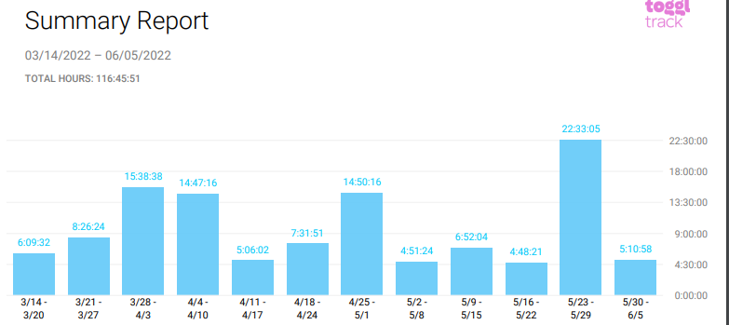

**Bradley van der Zwan**

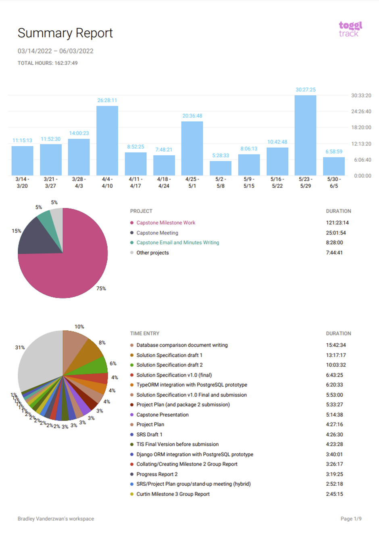

**Dillon Vincent**

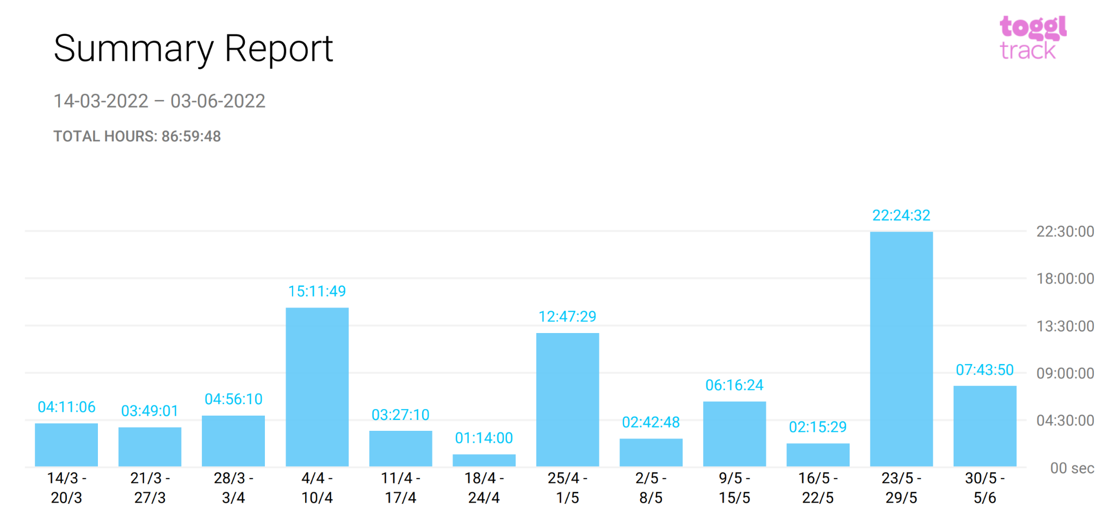

**Ryan Webster**

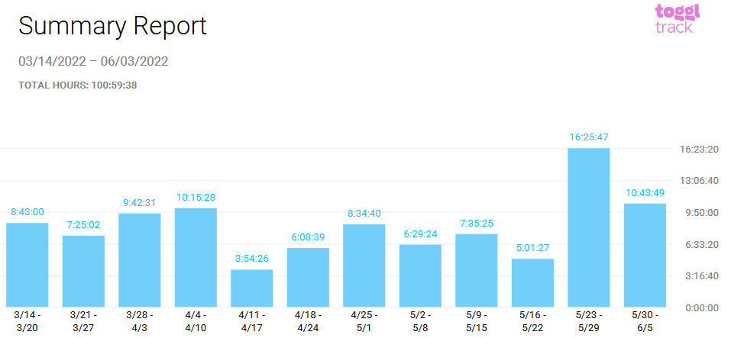

**Tanaka Chitete**

